Ideation Phase
Define the Problem Statements

Date | 18 June 2026
Team ID | -
Project Name | ShopEZ
Maximum Marks | 2 Marks

Customer Problem Statement Template:

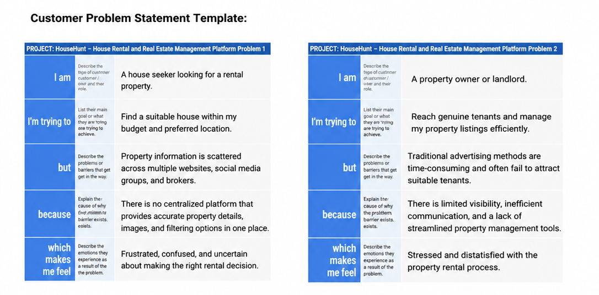

Problem Statement (PS) | I am (Customer) | I’m trying to | But | Because | Which makes me feel
PS-1 | An online shopper looking for products | Find quality products within my budget and preferences. | Product information is scattered across multiple websites and platforms. | There is no centralized platform that provides easy product discovery, comparison, ratings, and filtering options in one place. | Frustrated, confused, and uncertain about making the right purchase decision.
PS-2 | A store administrator managing products and orders. | Manage products, users, and customer orders efficiently. | Manual management of products and customer information is time-consuming and error-prone. | There is a lack of a centralized dashboard that streamlines product management, order tracking, and user administration. | Stressed, overwhelmed, and dissatisfied with the management process.

